**Step 1 - Modify the startup script**

Go to the tomcat installation folder -> bin folder.

For Windows OS, open **startup.bat** file with a text file editor.

Change the following line

***call "%EXECUTABLE%" start %CMD_LINE_ARGS%***

to

***set JPDA_ADDRESS=1043***

***set JPDA_TRANSPORT=dt_socket***

***call "%EXECUTABLE%" jpda start %CMD_LINE_ARGS%***

Similarly, for Linux OS, open **startup.sh** file with a text file editor.

Change the following line

***call "%EXECUTABLE%" start %CMD_LINE_ARGS%***

***exec "$PRGDIR"/"$EXECUTABLE" start "$@"***

to

***export JPDA_ADDRESS=1043***

***export JPDA_TRANSPORT=dt_socket***

***exec "$PRGDIR"/"$EXECUTABLE" jpda start "$@"***

**Step 2 – Deploy the web application to Tomcat and restart it**

Deploy your web application to the Tomcat and start it with startup.bat or startup.sh based on your OS.

**Step 3 – Verify that Tomcat is listening on the JPDA port number mention in the startup script**

Verify that when startup.bat or startup.sh is run, the first line prints like

***Listening for transport dt_socket at address: <the jpda port number>***

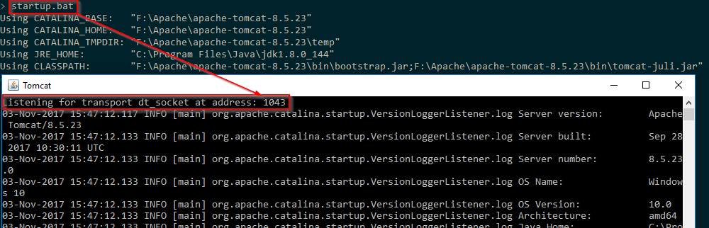

**Step 4 – Import the web project to be debugged in Eclipse**

In your Eclipse editor, import the web project you want to debug.

**Step 5 – Configure the project to debug it on remote Tomcat**

In your Eclipse editor, import the web project you want to debug.

Then ***Right Click on the project ->Debug As ->Debug Configuration***

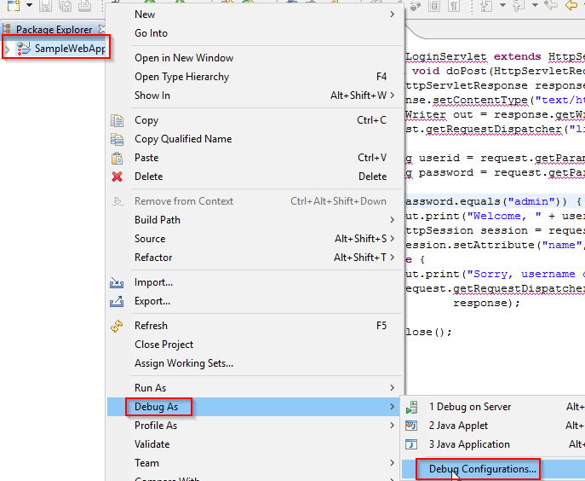

***Right Click on “Remote Java Application” ->New***

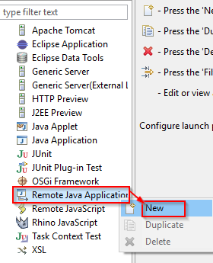

***Enter the IP of the machine where Tomcat is running and the port number set for JPDA_ADDRESS***

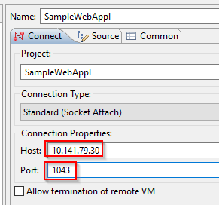

***Click on “Source” tab ->Add->Java Project->OK***

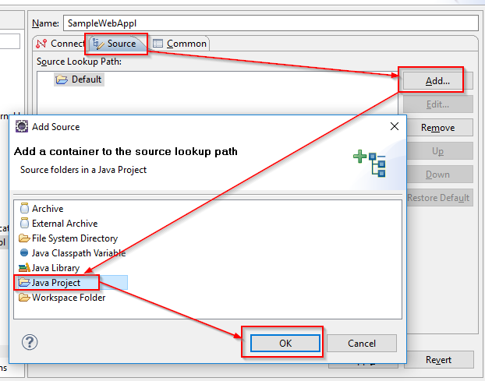

***Select the checkbox against the project to be debugged ->Click OK***

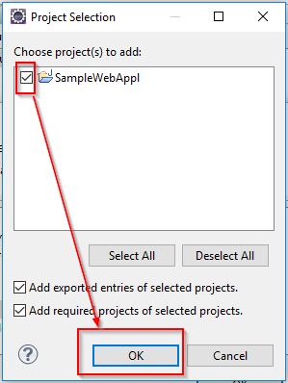

***Click on Apply->Debug***

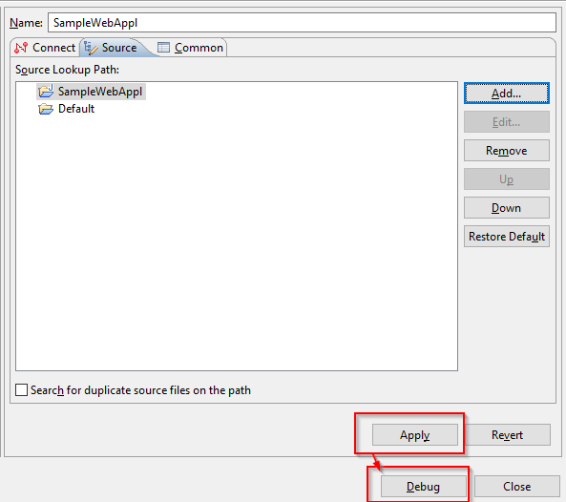

***Place break points in the files which you want to debug.***

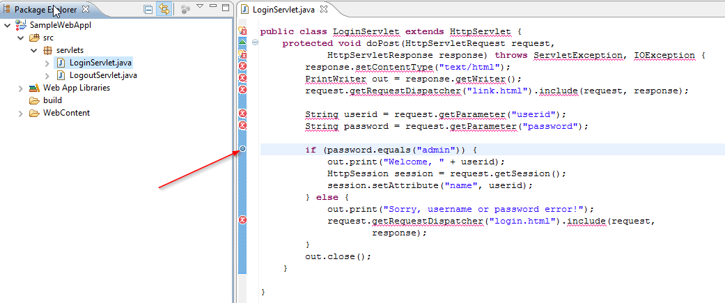

**Step 6 – Access the web application**

Open the web application page, enter the credential values and click submit

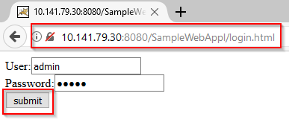

**Step 7 – Check the breakpoints hit in Eclipse**

The breakpoints will get hit in the Eclipse editor.

